1. What do you mean by AutoComplete feature in Excel and what are the benefits of using this feature?

Ans : AutoComplete feature in excel is the feature that tends to attempts or predict current word or phrase automatically. This feature of excel is use in data validation, formula predictions and reduce the syntax error.

1. Explain working with workbooks and working with cells.

Ans : A workbook is collection of various sheets and these sheets are made by intersection of row and column which is known as cell.

1. What is fill handle in Excel and why do we use it?

Ans : Fill handle in excel also known as autofill feature in excel is use to copy the formula in the following adjacent cell by dragging it or by double clicking it. It is also used to fill in the sequential data like indexes, day name, month name, repeating text, odd number series, even number series, and many more.

1. Give some examples of using the fill handle.

Ans : Just type first 2 or 3 values in the cells, select those values and you will find plus mark on the selected rows/column on the right bottom, drag that further to that cell till which we require the values. For example we just have to type Jan, Feb and select

both and drag them we get Jan, Feb, Mar, Apr,… , Nov, Dec.

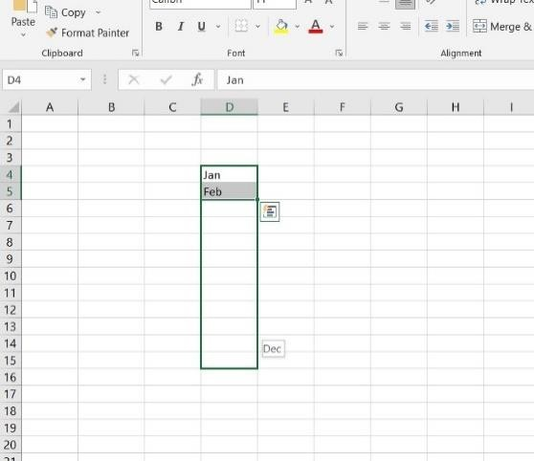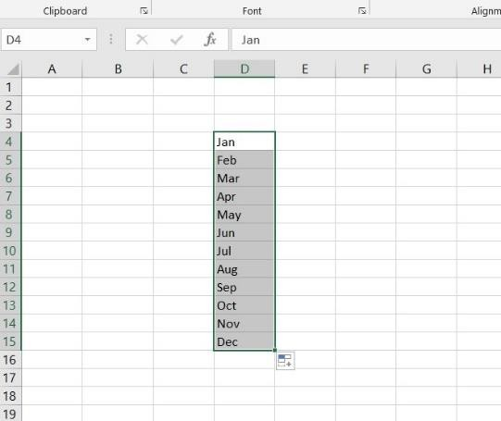

1. Describe flash fill and what the different ways to access the flash fill are.

Ans : Flash fill feature is the most amazing feature in excel it can reduce the time and complexity of the tedious task. We just have to provide 1 or 2 values in the adjacent column based on the matches with dependent column as shown below.

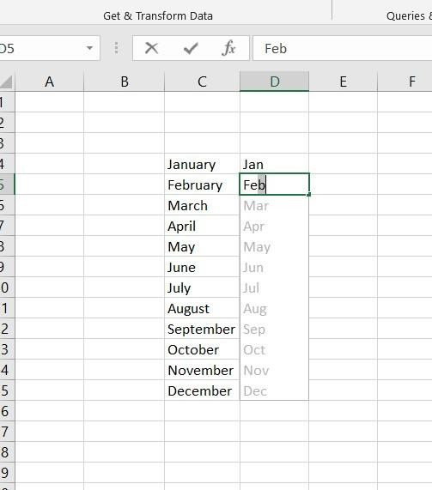

Same can be used to fetch first name/last name from the full name field & pin- code/country/street address from the Full address field, etc. By using “Ctrl” + “E” also it can be executed.

1. Extract first name and last name from the mail id and then from the address column, extract the city, state, and pin code using the flash fill. Given below is an example of the columns you have to create. Paste the screenshot of what you have created using the flash fill command.

Example: Mail Id, Address, First name, Last name, State, City, Pincode?

Ans : The sheet containing Mail Id columns consists of combination of first name and last name separated by dot(.) and address column consists of state, city and pincode separated by comas(,).

